**DEADLY MACHINES OF ANCIENT TIMES**

**-***Payal Mangla, BVCOE*

We often say “though we cannot decide how we take birth on earth but, we can at least have a thought about how we would like to die”. Now, let me tell you that there was a time when people were not even given the freedom to think. They did not have any rights, and even a small offence committed by them led towards torture or death. Death machines in ancient times were designed to provide the highest degree of torture and were very advanced. All these were used with a belief that these types of punishments would teach a lesson to the guilty and help cleanse the society. After knowing about these machines, I bet you would rather feel sorry for the criminal or the guilty!

Let us now start having a look at some of these devious devices.

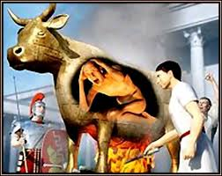

**THE BRAZEN BULL**

This was an execution device which was used by the ancient Greek. The

bull was made up entirely of bronze and was hollow

from inside with a door on one side. The guilty was put inside

and locked, with a fire lighted beneath the bull.

The metal was heated until the person inside was roasted to

death. Screaming of the person was used to

entertain the people and the executioners around! Can you

even picture this! Limit of cruelty!

**THE RACK**

Again designed for brutality. It contained a

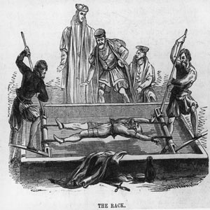

rectangular platform with two rollers attached on

either side. The guilty was made to lie down,

his wrists and feet were chained to the respective

rollers and then with the help of a pulley, the

rollers were rolled along and also the chains.

This increasing force stretched the

victim’s body, giving excruciating pain. Thai was continued

till the victim’s shoulder and hip

joints broke leading to death. lets just move on to the next one.

**THE PENDULUM.**

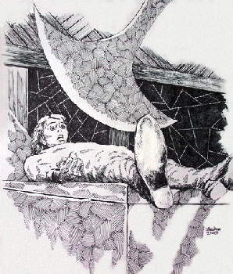

Personally, I think this is the worst on crossing all limits of

torture and pain. In this, the guilty

was made to lie down on a rectangular

platform and was tied to it. Above him was a

blade which was made to swing to and fro,

and it was gradually lowered. This lead to gradual cutting

of the victim’s stomach and intestines.

This was done slowly for at least 1-2 days.

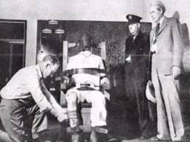

**THE ELECTRIC CHAIR.**

The victim was tied to the chair and two electrodes

were attached to his body, one on the head and

the other on the leg to create a closed path for the

current to flow. And then, current was passed

through the victim’s body, gradually raised to

2000 volts, leading to the immediate death.

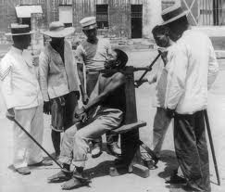

**THE GARROTE**

The person was tied to a wooden stake with

the help of a rope around his neck. This rope was

twisted and tightened by the executioner till the

person died. As technology improved, the wooden

stake was replaced by a wooden chair and the rope with

a metal band.

These were just a few, there were many. So what do you think now? Was this the apt way of punishing? Was this the apt usage of machines?